
God kept His promise and brought His people into their own land. God raised up leaders called judges. He also raised up prophets who gave the people messages from God and helped to remind them that He was in charge. God’s people asked for a king to rule. In this series, your kids will discover what it means for God to be the only true God and how He invites us to follow and respond to Him.
Series Overview
Bible Story | Bible Passage | Wonder Truth
The Rise and Fall of Saul | 1 Samuel 8–10; 13; 15 | God Is in Charge
David Spares Saul’s Life | 1 Samuel 26 | God Helps Us
Building of the Temple | 1 Kings 8 | God’s Presence Dwells with His People  *God Dwells with His People
Elijah and the Prophets  of Baal | 1 Kings 18 | God Is the Only True God
Josiah and the Book  of the Law | 2 Kings 22–23;  2 Chronicles 34 | God Delights in Our Obedience
Jeremiah and the Scroll | Jeremiah 36 | God Invites Us to Respond to Him
*Early Childhood

WORD OF WONDER
Be still, and know that I am God. I will be honored among the nations. I will be honored in the earth. The Lord who rules over all is with us. The God of Jacob is like a fort to us. —Psalm 46:10–11
*Be still, and know that I am God. —Psalm 46:10a


FAMILY WONDER QUESTIONS
- Who is in charge of you? How do you know that person is in charge?
- How do you like to spend time with God?
- What are some ways God speaks to us?
Family Spiritual PracticeS
- Be Still in God’s Presence: Turn off the lights and build a simple fort out of a blanket or bedsheet and a few chairs. Sit in the fort (your “temple”) and be still in God’s presence. We don’t need a temple now because our bodies are the temple, or home, of the Holy Spirit. Thank God for His presence with us.
- Prayer Scrolls: In Jeremiah 36, Jeremiah hears a message from God, and it’s written onto a scroll. God invites us to listen to Him and respond to Him too. Spend time listening for God and write or draw on a paper what He says. Then roll it into a scroll as a reminder of the story and a reminder that we can listen to God.
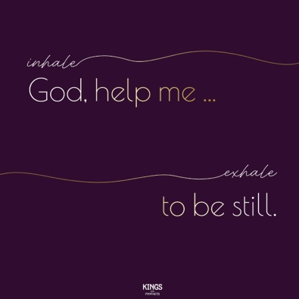
BREATH PRAYER
 |  | 
Scan for At-Home Bible Story Video YouTube® |  | Scan for Spotify™ playlist
A breath prayer is a word or phrase to repeat in a single breath with one part on the inhale and the other part on the exhale. Breath prayers help us focus on God and His presence with us.

Inhale: God, help me …
Exhale: to be still.

