
Personal connection comes through honesty. The Psalmists understood this better than anyone. From the pages of the Psalms leap lament and joy, anger and mercy—honest cries to the God who hears us and knows us. During this series, your kids will discover more from the Psalms about the unchanging character of God—the loving, caring, faithful shepherd—and your identity as His kids, wonderfully and purposefully created.
Series Overview
Bible Story | Bible Passage | Wonder Truth
I Am Fearfully and Wonderfully Made | Psalm 139 | God Made Me on Purpose, for a Purpose
The Lord Is My Shepherd | Psalm 23 | God Cares for Us
God’s Word Is a Lamp to My Feet | Psalm 119 | God Gives Us the Bible to Know Who He Is
God’s Love Endures Forever | Psalm 103; 136 | God’s Love Is Faithful
I Can Praise God with a Joyful Heart | Psalm 63; 108 | God Is Worthy of Praise
*Early Childhood

WORD OF WONDER
You created the deepest parts of my being. You put me together inside my mother’s body. How you made me is amazing and wonderful. I praise you for that. What you have done is wonderful. I know that very well. —Psalm 139:13–14
*How God made me is amazing and wonderful. —from Psalm 139:14


FAMILY WONDER QUESTIONS
- What is your favorite worship song, and why?
- When do you praise God?
- Share about a Bible story or verse that has helped or encouraged you.
Family Spiritual Practice
- Write a Psalm: The book of Psalms is filled with song poems to praise God. Give each person a paper and coloring utensils. Read Psalm 63 aloud as a family and invite each person to draw or write a picture or description of what they feel. You can write your own psalm or anything you want to say to God to praise Him.
- Imaginative Psalm 23: Listen as one person reads Psalm 23. As you listen, use all of your senses to imagine that you’re in the scene. What sounds do you hear? What does the grass (and sheep!) smell like? What does the water and grass feel like? What do you see? What do you feel as you walk through the dark valley or have oil poured on your head? What food would be at the table? Talk about it together and thank God for being our shepherd.
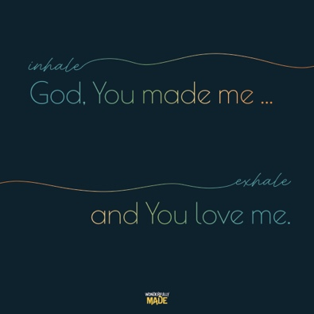
BREATH PRAYER
 |  | 
Scan for At-Home Bible Story Video YouTube® |  | Scan for Spotify™ playlist
A breath prayer is a word or phrase to repeat in a single breath with one part on the inhale and the other part on the exhale. Breath prayers help us focus on God and His presence with us.

Inhale: God, You made me …
Exhale: and You love me.

