
What does it look like to be like Jesus? God invites us to look more like Jesus each month, year, and decade of our lives. Yet all our determination and best effort will not get us there. It is only with the help of God’s Spirit that we become like Jesus. During this series, you’ll explore teachings from the New Testament that will lift the burden of self-powered character development and reveal the freedom that comes when we partner with the Holy Spirit on the journey of becoming like Jesus.
Series Overview
Bible Story | Bible Passage | Wonder Truth
Fruit of the Spirit | Galatians 5 | God Helps Us Be Like Jesus
Unity | Ephesians 4 | God Brings Us Together
Joy and Contentment | Philippians  2–4 | God Gives Us Joy and Contentment  *God Gives Us Joy
Faith | Hebrews 11 | God Is Faithful and Good
*Early Childhood

WORD OF WONDER
But the fruit the Holy Spirit produces is love, joy and peace. It is being patient, kind and good. It is being faithful and gentle and having control of oneself.
—Galatians 5:22–23a
*The fruit of the Spirit is love, joy, peace, patience, kindness, goodness, faithfulness, gentleness, and self-control. —Galatians 5:22-23a (ISV)


FAMILY WONDER QUESTIONS
- Which of the fruit of the Spirit is most challenging for you?
- When do you feel most joyful?
- Share about someone whose faith has inspired and encouraged you.
Family Spiritual Practice
- Fruit Prayer: Read Galatians 5:22–23a. Gather as many different fruits as you can find and take turns tossing the fruit to one another. Each time someone catches a fruit, name one fruit of the Spirit. End by praying together to ask the Holy Spirit to grow the fruit of the Spirit in your family.
- Filled with Joy and Contentment: Read Philippians 4:11–13 aloud. Gather a sponge, a bowl, and a cup of water. Hold up the sponge. Without Jesus, we’re empty inside. Let someone wring out the dry sponge (nothing happens!). No matter what we have, nothing can fill us with joy and contentment like Jesus. When we follow Jesus, He fills us with joy and contentment. Pour water on the sponge and wring it out into the bowl. Jesus fills us so we overflow. We can thank Him and find joy and contentment in Him.
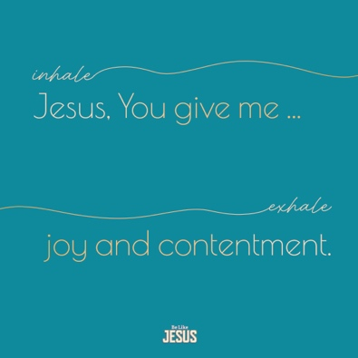
BREATH PRAYER
 |  | 
Scan for At-Home Bible Story Video YouTube® |  | Scan for Spotify™ playlist
A breath prayer is a word or phrase to repeat in a single breath with one part on the inhale and the other part on the exhale. Breath prayers help us focus on God and His presence with us.

Inhale: Jesus, You give me …
Exhale: joy and contentment.

