
God promises His Holy Spirit to every person who trusts in Jesus. The Spirit isn’t reserved only for Christians who’ve been walking with God for decades. The Holy Spirit is for everyone who believes! There’s no such thing as a junior-sized version of the Holy Spirit. The very same Spirit who raised Christ from the dead fills kids, helps them, and gives them strength and boldness!
Series Overview
Bible Story | Bible Passage | Wonder Truth
Jesus Gives the Great Commission and Ascends | Matthew 28; Acts 1 | Jesus Promises to Send the Holy Spirit  *Jesus Sends the Holy Spirit
Jesus Sends the Holy Spirit (Pentecost) | Acts 2 | The Holy Spirit Empowers Us to Share God’s Story
The Role of the Holy Spirit | Luke 11; John 14; Galatians 5 | The Holy Spirit Helps and Guides Us
Peter and John Before  the Sanhedrin | Acts 3–4 | The Holy Spirit Helps Us Be Bold
Peter and Cornelius | Acts 10 | The Holy Spirit Is for Everyone  Who Believes
Armor of God | Ephesians 6 | The Holy Spirit Gives Us Strength
*Early Childhood

WORD OF WONDER
But you will receive power when the Holy Spirit comes on you. Then you will tell people about me in Jerusalem, and in all Judea and Samaria. And you will even tell other people about me from one end of the earth to the other. —Acts 1:8
*The Holy Spirit gives us power. —from Acts 1:8


FAMILY WONDER QUESTIONS
- Share about a time when you were bold for God.
- How do you need the Holy Spirit to help you this week?
- Why do we need the armor of God? How does the armor help us?
Family Spiritual Practice
- Great Commission Mission: Jesus gave the Great Commission in Matthew 28:19–20 to His followers, commanding them to share the good news with others all over the world. Think and pray together as a family for someone in your lives who needs to hear the good news. Pray for that person and together, share the story of Jesus with them.
- Armor of God Prayer: Read Ephesians 6:10–18 aloud, then pray over your kids while laying hands on their body (if they’re comfortable with it). Pray the following: Helmet of Salvation: May they know Jesus and His salvation. Protect their minds. Breastplate of Righteousness: May they trust in Jesus. Protect their hearts. Shield of Faith: Give them strong faith in Jesus. Belt of Truth: Help them know and live in God’s truth. Shoes of the Gospel of Peace: May they walk in peace and share God’s love. Sword of the Spirit: May they know and love God’s Word.
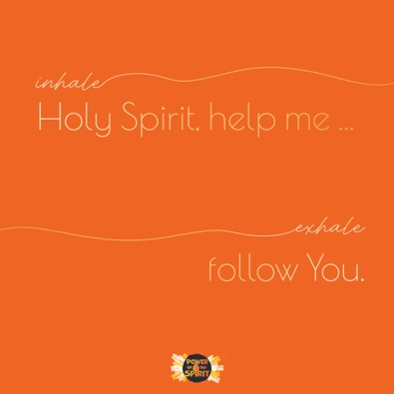
BREATH PRAYER
 |  | 
Scan for At-Home Bible Story Video YouTube® |  | Scan for Spotify™ playlist
A breath prayer is a word or phrase to repeat in a single breath with one part on the inhale and the other part on the exhale. Breath prayers help us focus on God and His presence with us.

Inhale: Holy Spirit, help me …
Exhale: follow You.

