
A rugged cross: the old is gone. An empty grave: the new has come. Because of Jesus, we are made new! During this series, kids will explore the story of redemption—a story that began at creation and the fall, climaxed at the crucifixion and resurrection of Jesus, and continues through all who walk in new identities as God’s children! Easter isn’t merely an ancient story disconnected from our modern reality. The story of Easter reaches into our lives and changes the very core of who we are!
Series Overview
Bible Story | Bible Passage | Wonder Truth
Creation: Made in God’s Image | Genesis 1–2 | God Made Us in His Image
The Fall | Genesis 3 | God Never Gives Up on Us
The Crucifixion | Matthew 27 | Jesus Showed His Love by Dying for Us
The Resurrection | Luke 24 | Jesus Is Alive!
New Creation | Romans 5 | Jesus Makes Us New
*Early Childhood

WORD OF WONDER
When anyone lives in Christ, the new creation has come. The old is gone! The new is here! —2 Corinthians 5:17
*Jesus makes us new. —from 2 Corinthians 5:17


FAMILY WONDER QUESTIONS
- What is your favorite thing in creation that God made?
- What does it mean for people to be made “in the image of God”? How can you reflect God’s image?
- How can you celebrate this Easter season that Jesus is alive?
Family Spiritual Practice
- Fasting for Lent: The season of 40 days (excluding Sundays) leading up to Easter is called Lent. Many Christians fast, or deny themselves, during that time to focus fully on Jesus. While kids don’t need to give up food, come together as a family during the season leading up to Easter and determine something that your family could give up (such as media) to focus more on Jesus. Spend extra time in prayer.
- New Creation Prayer: Listen as one person reads aloud Romans 5:6–11 and then write or draw a picture of a prayer to God and tell Him how you feel knowing that Jesus died for us. Then thank God for making us new creations through Jesus. Look for something outside that reminds you that you’re a new creation (such a blooming flower).
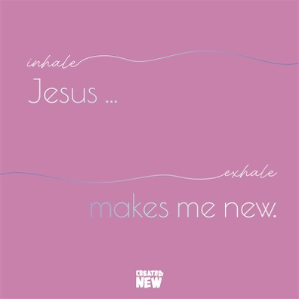
BREATH PRAYER
 |  | 
Scan for At-Home Bible Story Video YouTube® |  | Scan for Spotify™ playlist
A breath prayer is a word or phrase to repeat in a single breath with one part on the inhale and the other part on the exhale. Breath prayers help us focus on God and His presence with us. Try this together as a family.

Inhale: Jesus …
Exhale: makes me new.

