
Everywhere Jesus walked, people were changed. In this series, kids will encounter a Jesus who is fully loving yet unfathomably powerful, a Jesus whose words command nature to obey and whose compassion for the hungry crowds compels Him to do the impossible. Kids will hear about Jesus healing a man who was blind and a sick woman, commanding a girl who has died to get up, and strolling across storm-tossed waters. Kids will encounter a miracle-working Jesus who sees them, loves them, and will stop at nothing to be with them.
Series Overview
Bible Story | Bible Passage | Wonder Truth
Jesus Calms the Storm | Mark 4 | Jesus Has Power over Creation
Jesus Feeds the 5,000 | Matthew 14 | Jesus Shows Compassion
Jesus Heals a Man Who Is Blind | Mark 10 | Jesus Has Power to Heal
Jesus Heals Jairus’ Daughter | Mark 5 | Jesus Is Powerful
Jesus Walks on Water | Matthew 14 | Jesus Is the Son of God
WORD OF WONDER
How great God is! We’ll never completely understand him.
—Job 36:26a


FAMILY WONDER QUESTIONS
- Which of Jesus’ miracles is the most interesting to you, and why?
- What do you need Jesus’ power for in your life?
- Share about something God has done for you or helped you with.
Family Spiritual Practices
- Drawing Storms: In Mark 4, we read about Jesus calming a storm with wind and waves. Read Mark 4:39–41 and give everyone paper and coloring utensils to draw what they envision as they listen. Then draw a picture of a storm or worry in your life that you need a reminder of God’s power over. Pray and thank God for being powerful.
- Water Worship: In Matthew 14, we read about Jesus walking on water. Afterwards, His disciples worshiped Him and said, “You really are the Son of God!” (Matthew 14:32). Sing a worship song and worship together as you think about Jesus and how amazing He is. While you worship, pour water into a bowl and think about how Jesus walking on water showed His power and His nature.
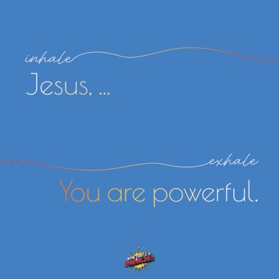
BREATH PRAYER
 |  | 
Scan for At-Home Bible Story Video YouTube® |  | Scan for Spotify™ playlist
A breath prayer is a word or phrase to repeat in a single breath with one part on the inhale and the other part on the exhale. Breath prayers help us focus on God and His presence with us. Try this together as a family.

Inhale: Jesus, …
Exhale: You are powerful.

